**Whisk and Flour Bakery**

**MODULE:** Business Analysis 3.2

**MODULE CODE:** AIBUY3A

**GROUP NAME:** Whisk and Flour Bakery

**Due DATE:** 13 October 2025

**MODULE LECTURER:** Malefetsane Matsela

**GROUP MEMBERS:**

|  |  |  |  |  |
| --- | --- | --- | --- | --- |
| **Student Number** | **Initials** | **Surname** | **Group code** | **Signature** |
| 222049812 | IL | Mofokeng | C4 |  |
| 223317713 | EN | Mabasa | C3 |  |
| 223006351 | T | Molefe | C5 |  |
| 224173553 | C | Blessie | C1 |  |
| 223059854 | JW | Tiva | C4 |  |
| 222249609 | SM | Dlomo | C5 |  |

Table of Contents

Declaration 2

AI Solution - DOCUMENTATION ASPECT: 4

Business objectives 4

**Business Background/Theme** 6

PROBLEM DEFINITON 8

AI Solution - THEORETICAL ASPECT: 9

Machine Learning Approach 9

Data 10

Model 11

Solution Techniques 11

Other Features (Chatbot/Softbot) 12

AI Solution (PRACTICAL) 13

Grammarly Report 18

References 19

# Declaration

**Declaration of Original Work**  
We, the undersigned, hereby declare that the work/assignment submitted is our own original work. We affirm that:  
  
We have not engaged in plagiarism, nor have we used unauthorized materials or content from other sources without proper acknowledgment. All group members have actively contributed to the completion of the work. Any references, data, or ideas that are not our own have been cited appropriately according to the required referencing style. This submission has not been previously submitted, in whole or in part, to fulfill the requirements of any other course, assignment, or academic task. We understand that failure to adhere to these conditions may result in disciplinary actions in accordance with institutional policies on academic integrity.

|  |  |  |
| --- | --- | --- |
| **Student No.** | **Date** | **Signature** |
| 222049812 | 12/10/2025 |  |
| 223317713 | 12/10/2025 |  |
| 223006351 | 12/10/2025 |  |
| 224173553 | 12/10/2025 |  |
| 223059854 | 12/10/2025 |  |
| 222249609 | 12/10/2025 |  |

By signing above, each participant acknowledges that they have read, understood, and agree to the terms stated in this declaration.

# AI Solution - DOCUMENTATION ASPECT:

The Whisk & Flour AI Demand Forecasting and Recommendation System aims to transform bakery operations by combining predictive analytics with conversational AI. The system comes in two primary areas of interest: first, it uses machine learning and time series forecasting methodologies to analyze historical sales data and external data in an attempt to accurately predict on a daily and weekly basis demand for bakery products such as cakes, pastries, and breads. These forecasts enable the bakery to optimize inventories, reduce excess production waste, and avoid going out of stock of top-selling products. Second, the system also includes an NLP chatbot that converses with customers, identifies their dietary needs and product interests, and provides them with customized recipe or menu recommendations. By automating demand planning and customer interaction, this AI product increases operational efficiency, reduces costs, improves customer satisfaction, and enables data-driven decision-making. It continues the theme of leveraging artificial intelligence for industrial gain by digitizing an antique bakery with intelligent forecasting and customized customer interaction.

## Business objectives

**1.Improve Operational Efficiency**

* Accurately forecast demand in order to prevent over- and underproduction.
* Streamline purchasing ingredients and reduce on-hand waste.

**2. Enhance Customer Experience**

* Provide personalized recipe and product recommendations through a chatbot.
* Reduce wait times at peak hours with AI-powered ordering.

**3. Increase Profit**

* Align production to existing customer demand to save costs and make more sales.
* Drive trending or high-margin products intelligently.

**4. Leverage Data for Strategic Decisions**

* Track sales trends to inform product innovation, marketing campaigns, and seasonal promotions.

**Business Success Criteria**

1. **Forecasting Accuracy**

* **Provide at least 85% day-to-day and week-to-week product demand forecast accuracy for the first three months.**
* **Accurately perform forecasting at anticipated levels during seasonal holidays and special occasions.**

1. **Operational Efficiency**

* Remove at least 30% waste caused by overproduction through improved planning of stock.
* Improve stock availability to 95% on best-selling items during peak seasons.
* Decrease manual planning time for staff by 40%, allowing them to focus on primary business bakery activity.

1. **Customer experience**

* At least 70% of customers utilize the chatbot for orders or recommendations in six months.
* Maintain a minimum average rating of 90% or higher on customer satisfaction with chatbot interaction, as evidenced by feedback surveys.
* Reduce average customer wait time during busy hours by at least 25%.

1. **Financial Performance**

* Increase overall sales revenue by 15% within the first year, through accurate forecasting and well-focused recommendations.
* Accrue positive return on investment (ROI) due to cost savings generated by reduced waste and increased sales margins.

**Requirements**

**1.Functional Requirements**

* The system must analyze historic sales data to generate daily and weekly forecasted demands for all products.
* The system must provide inventory and manufacturing recommendations based on forecasted demand to minimize waste and prevent stockouts.
* There must be an NLP-based chatbot that has the ability to allow customers to order, get product suggestions, and ask for dietary choices (e.g., vegan, gluten-free).
* The chatbot must be able to classify customer preferences and provide suitable menu recommendations accurately.
* The system must provide dashboard access for bakery staff to track forecasts, inventory recommendations, and user interaction analytics of the chatbot.

**2. Non-Functional Requirements**

* The system must provide high forecasting accuracy levels (target: at least 85%) and reliable chatbot responses.
* The solution must be scalable such that additional products, stores, or data sources can be added easily in the future.
* It must be user-friendly and easy to operate, with minimal technical expertise required for bakery staff.
* The chatbot will respond to customer inputs within 2–3 seconds to ensure a smooth user experience.
* It will be operational 95% of the time when business is open.

## **Business Background/Theme**

Whisk & Flour is a growing artisan bakery that produces cakes, pastries, breads, and desserts. Issues facing the business are inadequate demand forecasting, food wastage as a result of overproduction, stockouts, and insufficient one-on-one customer service. Production planning is not currently automated and is experience-based rather than data-driven, making it inefficient. The project aligns with the 4IR as it entails the adoption of AI technologies in a traditional bakery environment. The system applies time series prediction to predict the demand for products to improve stock management and an NLP chatbot to provide personalized product suggestions. In doing so, it brings intelligent automation and data-informed decision-making to the food and retail sector to improve efficiency and customer experience.

**Risks**

1. **Data Quality Risk**

* Data Quality Risk: Poor or conflicting historical sales information could lead to inaccurate demand projections and inventory issues.

1. **Adoption Risk**

* Adoption Risk: Staff or customers may be hesitant to use AI technologies like chatbots or forecasting systems, affecting effectiveness in general.

1. **Technical Risk**

* Technical Risk: Integration with existing bakery infrastructure could have compatibility problems, requiring extra development time.

1. **Security Risk**

* Security Risk: Processing customer information requires strict compliance with privacy legislation; any failure can spoil reputation and trust.

1. **Model Performance Risk**

* Model Performance Risk: Unforeseen factors like holidays or load shedding may disrupt forecast accuracy, leading to over- or underproduction.

**Constraints**

1. **Budget**

* The project has limited budgets, meaning that access to advanced infrastructure, the best APIs, or commercial data is not possible. This may require the utilization of open-source tools and free-tier offerings

1. **Time**

* Development has to be within academic timeframes, with minimal opportunity for extensive testing, iterative tuning, or delayed deployment. All milestones must be completed within the semester timeframe.

1. **Data**

* Having clean, formatted, and relevant historical sales data is a must. Inadequately formatted or incomplete data can cause hindrances in training models and reduce forecasting accuracy.

1. **Integration**

* The AI assistant must integrate with existing bakery systems (POS, inventory, CRM), and there may be a need for custom connectors or workaround solutions as there may be compatibility issues.

1. **Regulatory Compliance**

* The system must be compliant with data protection laws such as POPIA, which can restrict the way customer data is collected, stored, and used.

**Initial Assessment of Tools and Techniques**

**1.Machine learning**

* Scikit-learn, statsmodels, and Facebook Prophet libraries will be utilized to implement time series forecasting models. The above libraries will be used to forecast ingredient demand based on past sales patterns, seasonality, and customer behavior.

**2.Natural Language Processing**

* Natural Language Processing (NLP): Simple text classification and keyword extraction techniques will be utilized to power the recommendation engine of the chatbot. This allows the assistant to suggest baked goods dependent on customer ask and intent.

**3.Data handling**

* Data Processing: Pandas and NumPy will be used for data cleaning, data transformation, and data analysis. These libraries are essential for pre-processing structured data and performing statistical calculations required for model training.

**4. Data Visualization**

* Matplotlib will be used to create visual representations of sales trends, model performance, and demand forecasts.
* Visualization is needed to convey results and trends in a way that supports decision-making.

## PROBLEM DEFINITON

Enhancing Operational Effectiveness and Customer Experience in Whisk & Flour Bakery through AI Forecasting and Chatbot Solutions

Whisk & Flour Bakery, like the majority of small and medium-sized food retailers, faces a range of challenges that affect its operational efficiency, profitability, and customer satisfaction. These challenges vary from inaccurate demand forecasting, high levels of food waste, stockouts, and low levels of personalized customer engagement. The bakery currently uses manual estimation and staff experience to predict daily and weekly product demand. This approach has a tendency to result in overproduction or underproduction. Overproduction leads to increased costs and food waste, while underproduction leads to stockouts, lost sales opportunities, and customer disappointment. Seasonality, holidays, and random shifts in customer preferences add complexity to forecasting. In addition, when they are busy during peak periods, staff are occupied taking orders and lack the time to provide personalized recommendations to each customer, especially for diet-specific products such as gluten-free or vegan products. This leads to slower service, reduced upselling opportunities, and a lack of standard customer experience. Resolving these challenges through the use of AI-powered demand forecasting and chatbot solutions can benefit the bakery in several ways. By accurately predicting daily and weekly product demand, the bakery can consolidate ingredient procurement and production planning, significantly reduce waste, and have top-selling items always in stock. Personalized recommendations powered by chatbots can enhance customer experience as it enables the customer to find products matching their taste and dietary needs in real time. These changes can make the sales higher, resource allocation better, and the overall process more organized. The proposed AI system is directly aligned with the topic of leveraging AI for industrial benefits since it employs artificial intelligence in a traditional bakery environment to modernize the process.

# AI Solution - THEORETICAL ASPECT:

## Machine Learning Approach

In order to address the operational and customer experience challenges of the bakery sector, the solution employs two basic machine learning models: a Prophet time series forecasting model to forecast product demand and a Multinomial Naive Bayes classifier for product and recipe recommendation. Facebook's Prophet model is very well suited for forecasting time series data with daily and seasonal trends. It predicts future demand for each product based on past sales trends, enabling the bakery to plan its production and stock precisely. The text classification tasks of the chatbot, such as identifying customer preferences ("vegan," "sweet," "low-sugar") and suggesting suitable bakery items, are managed by the Naive Bayes Classifier. The process ensures fast and precise suggestions during customer interaction.

**Code:**

def forecast_enhanced(input_path="data/sales_cleaned.csv", output_dir="forecast_output", forecast_days=14):

df = pd.read_csv(input_path)

df["Date"] = pd.to_datetime(df["Date"])

products = df["Product"].unique()

for product in products:

product_df = df[df["Product"] == product]

daily_sales = product_df.groupby("Date")["Qty_Sold"].sum().reset_index()

daily_sales.columns = ["ds", "y"]

model = Prophet(daily_seasonality=True, weekly_seasonality=True)

model.fit(daily_sales)

future = model.make_future_dataframe(periods=forecast_days)

forecast = model.predict(future)

# Save forecast to CSV for evidence

forecast.to_csv(f"{output_dir}/{product}_forecast.csv", index=False)

# Optionally, plot and save the forecast

fig = model.plot(forecast)

fig.savefig(f"{output_dir}/{product}_forecast_plot.png")

## Data

The dataset contains daily sales records for key bakery products, structured by date, product name, and quantity sold. This allows the system to detect seasonal sales patterns and trends over time. For forecasting, the data is transformed into time series format with features like rolling averages, lag values, and calendar indicators to improve model accuracy. The chatbot uses a labeled text dataset of customer queries mapped to product categories, enabling personalized recommendations. Data balancing ensures fair predictions across both high- and low-volume products for demand forecasting and customer interaction.

**Code:**

products = {"Croissant": 15, "Baguette": 20, "Vegan Chocolate Tart": 25}

dates = pd.date_range("2024-01-01", "2024-08-31")

rows = []

for date in dates:

for product, price in products.items():

qty = random.randint(5, 35)

revenue = qty * price

rows.append([date, product, qty, price, revenue])

df = pd.DataFrame(rows, columns=["Date", "Product", "Qty_Sold", "Unit_Price", "Total_Revenue"])

df.to_csv("data/sales.csv", index=False)

## Model

The Whisk & Flour Bakery chatbot uses a Naive Bayes classification model to detect customer intent from text queries. It is trained on labeled examples such as “I want something vegan” to recognize categories like `vegan_request`. The model converts user input into numerical features using a vectorizer and predicts the intent in real time. Its performance is evaluated using accuracy metrics, ensuring reliable recommendations for customer requests like vegan options or product information.

**Code:**

X_test = vectorizer.transform(["I need vegan options"])

y_test = ["vegan_request"]

y_pred = model.predict(X_test)

print("Chatbot Accuracy:", accuracy_score(y_test, y_pred))

## Solution Techniques

For Whisk & Flour Bakery AI system, machine learning mechanisms and text preprocessing are utilized to enhance model credibility and accuracy. The customer queries are tokenized, cleaned, and transformed into numerical vectors by Count Vectorizer and then classified through Naive Bayes for providing precise real-time product recommendations through the chatbot. For demand forecasting, the models are learned on preprocessed historical daily sales data with features of rolling averages, lag variables, weekday and month indicators so that seasonality can be modeled well. These techniques enable accurate demand forecasting and detection of customer intent, and they form a robust AI-based solution for improving operational planning and customer experience at the bakery.

## Other Features (Chatbot/Softbot)

Besides product suggestion and intent identification, Whisk & Flour chatbot also provides several beneficial features that enhance user experience. It uses NLTK-based text processing to preprocess and tokenize the input from the user and remove stop-words for effective classification. The chatbot provides support for multiple dietary needs such as vegan, gluten-free, and sugar-free diets, and can reply to queries related to product details, best sellers, and order. A predetermined response dictionary helps guarantee that there are uniform responses, while the conversational loop allows users to respond naturally until they choose to leave. These features make the chatbot an efficient and responsive tool to consumers of bakeries

**Code:**

# Preprocess and predict intent

text = "I need something sweet and vegan"

processed = preprocess(text)

intent = model.predict(vectorizer.transform([processed]))[0]

print("Bot:", responses.get(intent))

# AI Solution (PRACTICAL)

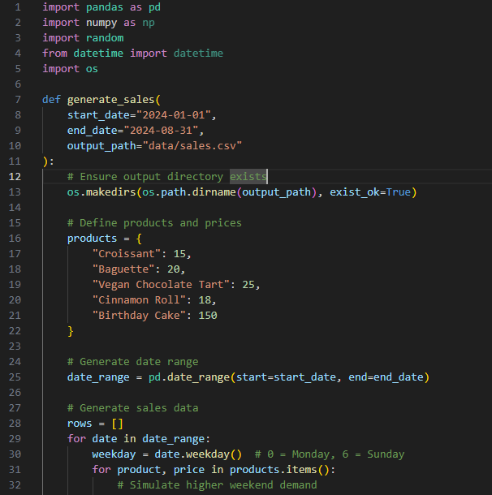

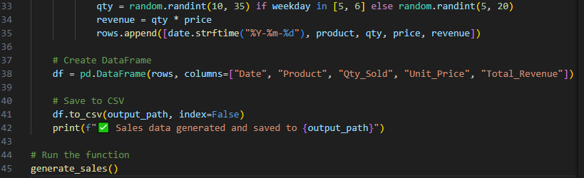

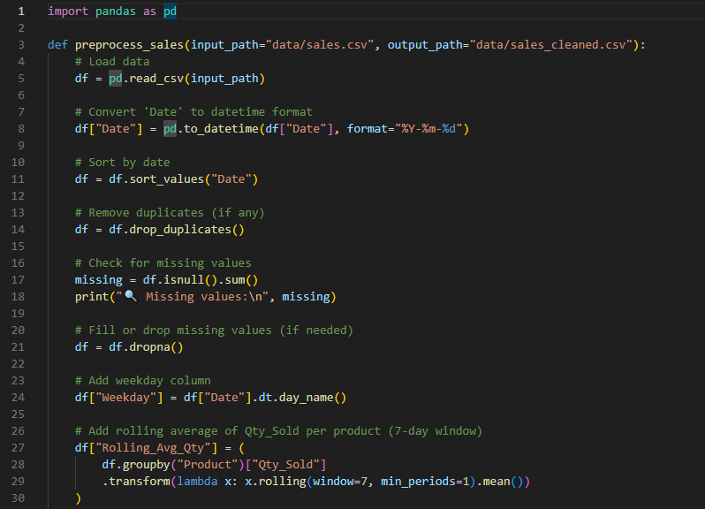

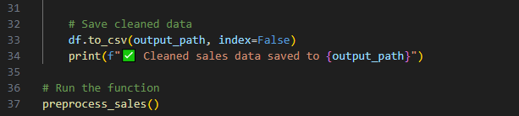

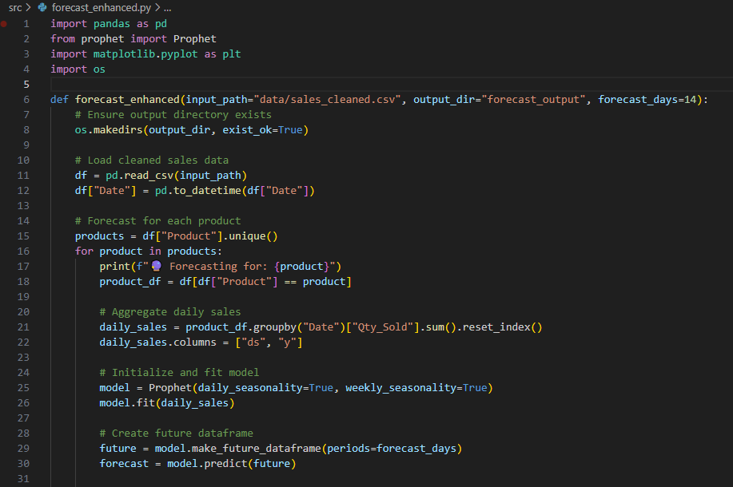

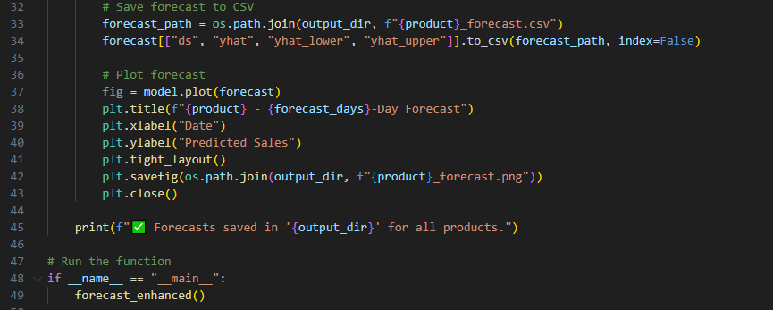

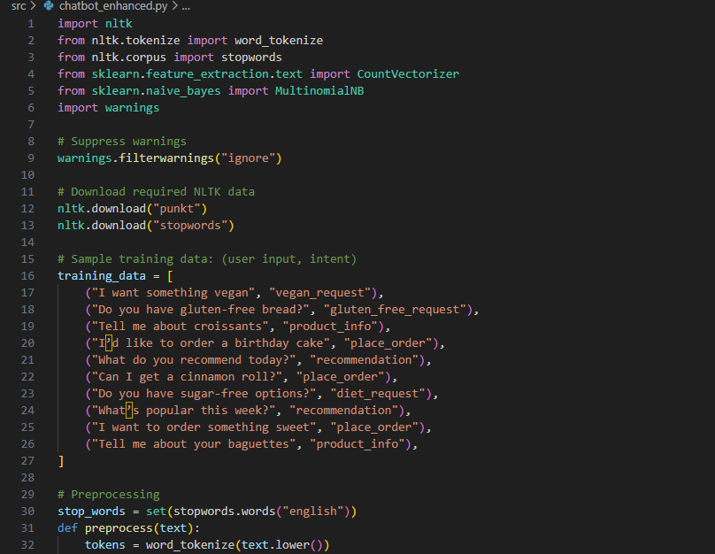

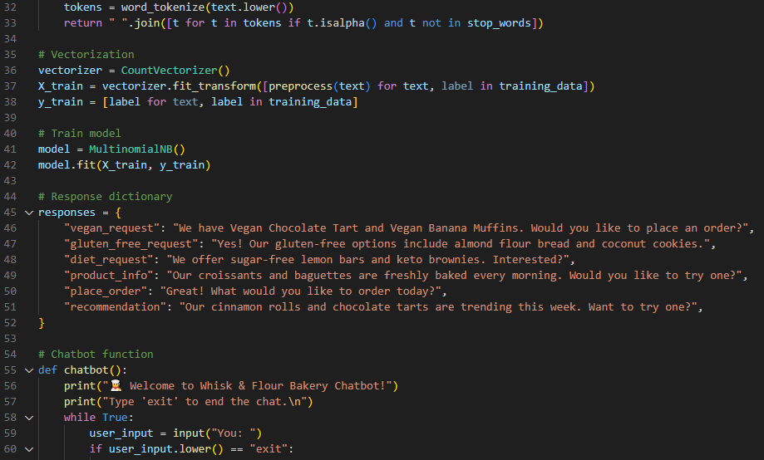

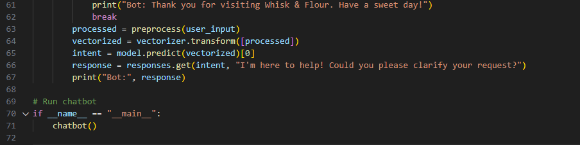

# Grammarly Report

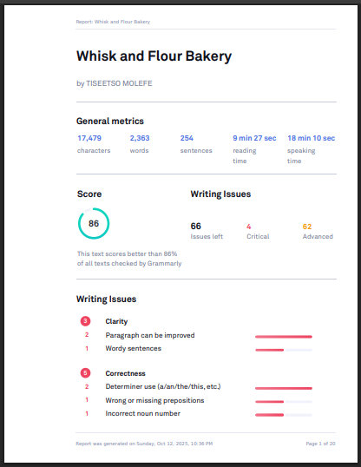

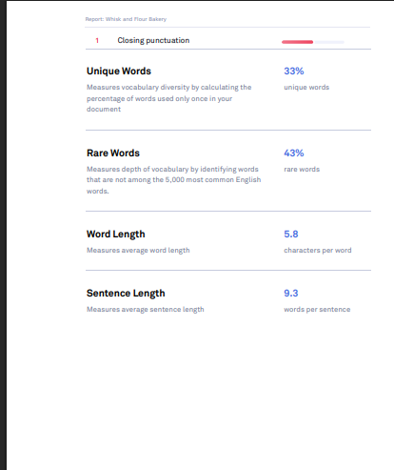

# References

* Tutorials Point (2016) *AI with Python*. Available at: [www.tutorialspoint.com] (Accessed: 02 September 2024)​(AI with Python).
* Matsela, M. (n.d.) *Lesson 3 - AI with Python - Part 1*. (Accessed: 15 October 2024)​(Lesson 3 - AI with Pyth…).